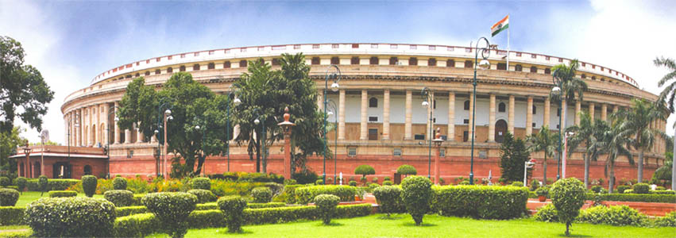

PRESS RELEASE

LOK SABHA SECRETARIAT
PARLIAMENT HOUSE
NEW DELHI

TWENTY FIRST REPORT (16th LOK SABHA) OF THE STANDING COMMITTEE ON RAILWAYS (2017-18) ON "NEW RAILWAY CATERING POLICY 2017”

7th August, 2018

Shri Sudip Bandyopadhyay, M.P. and Chairperson of the Standing Committee on Railways (2017-18), presented today in Lok Sabha the Twenty First Report of the Standing Committee on Railways on ‘New Railway Catering Policy 2017’. Some of the important observations/recommendations made in the Report are as follows:

Subject | Recommendations
Paradigm shift in catering business under the New Railway Catering Policy 2017 – desired. | The Committee realized that unless the basic problems and deficiencies which the Railways and IRCTC had experienced like supply of quality and hygienic foods and beverages including purified water to Railway passenger is addressed nothing is going to happen for betterment of catering services. Mere blaming the agencies responsible for lapses would not solve the problem. They hoped that new Railway Catering Policy 2017 would bring a paradigm shift in catering business through closely monitored units by creating a distinction between food preparation and food distribution and remove all earlier deficiencies.  (Para No. 3)
Effective implementation of New Catering Policy 2017 – desired. | Having noted frequent changes in Catering Policy affecting the efficiency of the system due to time slag in dealing with feeting problem of implementation and hitting the morale of the employees of the concerned agencies, the Committee hoped that the new Catering Policy 2017 would be implemented effectively in letter and spirit with no further changes in the system.  (Para No. 4)
Handing over of remaining catering services to IRCTC – desired. | The Committee have desired that for the implementation of New Catering Policy 2017 in letter and spirit, the Railway should hand over remaining catering services including Food Plazas and Food Courts to IRCTC urgently.  (Para No. 5)
Implementation of recommendation of New Menu and Tariff Committee – desired. | The Committee have desired that the Railways should closely examine the recommendations of the New Menu and Tariff Committee and implement them to avoid difficulties and demotivation to the parties concerned in the endeavour for betterment of catering services over Indian Railways under their intimation.  (Para No. 6)
Implementation of E-tendering module – recommended. | The Committee were of the view that E-tendering module for allotment of static catering units may be implemented and monitored so that contracts may be awarded commensurate to e-tendering module.  (Para No. 7)
Attachment of pantry cars in trains having run of more than 12 hours – desired. | The Committee hoped that in New Railway Catering Policy 2017, the trains having run of 12 hours or more would be provided with pantry cars and the trains upto 12 hours run and running with no pantry cars would be facilitated with train side vending and e-catering facilities on train enroute.  (Para No. 12)
Narrowing the time gap between food preparation and its distribution – emphasized. | The Committee have emphasized on narrowing the time gap between food preparation and its distribution and develop coordination between the agencies involved therein to ensure that prepared foods be as fresh as possible and reach the customers within the shortest time gap.  (Para No. 13)
Regular monitoring of Janta Meals – urged. | The Committee have urged the Ministry for regular monitoring of availability of Janta Meals at stations and ensure that the concerned agencies at the stations are alert towards their duties and responsibilities so that passengers and the Railways are benefited from the Scheme.  (Para No. 16)
Remedial measures to check unauthorized vending – urged. | Having strongly felt that unauthorized vending not only causes loss of revenues to Railways but also poses a health hazard to the passengers, the Committee urged the Ministry to immediately work out appropriate remedial measures to check unauthorized vending both in mobile units and at stations.  (Para No. 17)
Mandatory electronic receipt of sale of food articles – desired. | The Committee have perceived that measures like zero tolerance for bad quality of foods served to passengers, overcharging and making issue of electronic receipt mandatory for sale of every item for Indian Railways be implemented in all mobile and static units, food plazas and food courts with proper monitoring including stringent penal provisions for defaulters. They have desired that a policy of ‘No food bill, no payment’ may be adopted to refrain overcharging.  (Para No. 18)
Cashless transaction and computerized billing – desired. | The Committee have desired that concrete measures may be taken to ensure availability of POS/swipe machines with personnel along with regular monitoring thereof to ensure working condition of machines to avoid hardships to passengers in making payment so that catering services remain transparent and passenger-friendly.  (Para No. 20)
Availability of regional cuisines - desired. | The Committee have hoped that in New Catering Policy 2017, Railways would ensure availability of regional cuisines depending upon the area to optimize good catering services for their passengers over the network.  (Para No. 26)

